**Markov Decision Processes & Reinforcement Learning**

Anurag Sahoo  
[asahoo41@gatech.edu](mailto:asahoo41@gatech.edu)

GT ID: 90368005

**Abstract**— This paper deals with solving two MDP problems of different sizes using Value Iteration, Policy Iteration and Q Learning. I divided this paper into 3 different sections. First section delves into the two MDP problems including a grid and non-grid world. In the second section, we go deep into the algorithms we used to solve these problems. Third, we use Value Iteration, Policy Iteration and Q Learning to solve Frozen Lake of different sizes. Fourth, we use those three techniques to solve Forest Management problem of different sizes.

1. **Introduction to Problems**:

Frozen Lake: Frozen Lake is a grid world problem where an agent moves from start to goal without falling into holes by walking over the frozen block. There lies an element of stochasticity as the agent may not always move in the desired direction because of the slippery nature of frozen lake. The agent can take either of UP, DOWN, LEFT and RIGHT actions. Because of the stochasticity nature of the environment, the agent moves in the intended direction with a probability of 0.33 and ends up on either side with a probability of 0.33 each. The reward for reaching the goal is 1. I have used 8x8 and 15x15 map for small and large grid worlds respectively.

Forest Management: It is a non-grid problem where the forest grows up to maximum and the agent has the option to wait or cut. The action is decided with an objective to maintain an old forest for wildlife and to make money selling cut wood. There are certain rewards associated with each action. Also, there is a probability associated with the problem that the forest might catch fire. So, the agent must take a call if it wants to wait and go to final state for larger rewards with the risk of forest catching fire. I used two sets for this problem. The smaller one has 20 states, with reward of 10 for Wait when the forest is in its oldest state, reward of 2 for Cut when the forest is in its oldest state and a probability of 0.1 of forest catching fire. The smaller one has 400 states, with reward of 25 for Wait when the forest is in its oldest state, reward of 8 for Cut when the forest is in its oldest state and a probability of 0.05 of forest catching fire.

Why are these problems interesting?

These problems are interesting as they represent real world situations. The grid world problem Frozen Lake can be thought of analogous to robot navigating to move the desired box from start to goal in a warehouse setup. A positive reward would be given if the robot successfully moves the boxes to destination. There would be negative reward if the robot bumps into an obstruction. These problems can automate a whole lot of tasks and are used predominantly in the logistics space. The non-grid problem (Forest Management) is a typical example of risk-reward trade off problem. It finds application in the areas of Stock Market Trading where the user takes a call on each trading days if he/she exits the position and realizes the gain/loss or holds the position with the hope to gain more rewards but there is a certain element of risk of losing more.

1. **Techniques to solve MDP Problems**

Value Iteration**:** Value Iteration is a model-based learner in which we start with a random value function and find an optimal value function using an iterative process. The optimal policy can be generated from the optimal value function using the Optimality Bellman Operator. Hence, Value Iteration includes finding optimal value function and one policy extraction. Value Iteration guarantees convergence.

Policy Iteration: Policy Iteration is a model-based learner in which we start with a random policy and find the value function of that policy (policy evaluation), and then find improved policy based on the previous value function, and so on. The value function of a policy can be generated using Bellman Operator. Policy Iteration involves policy evaluation and policy improvement. Policy Iteration guarantees convergence with lesser iterations compared to Value Iteration.

Q Learning: Q Learning is a model-free learner in which we do not know the transition probabilities and rewards beforehand. Agent learns through the experience of interacting with environment. It is an off-policy temporal difference control algorithm. Q Learning is a temporal difference algorithm meaning the predictions are re-evaluated after taking a step. It is an off-policy algorithm in which it estimates the state-action pairs based on the greedy policy, independent of agent’s actions. Q Learning converges only under certain conditions: learning rates approach zero and each state-action pair are visited infinitely.

1. **Value Iteration, Policy Iteration and Q Learning on Frozen Lake problem**

Value Iteration, Policy Iteration and Q Learning were implemented in the Frozen Lake environment of size 8x8 (small grid) and 15x15 (large grid).

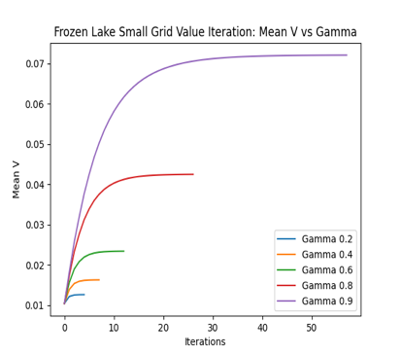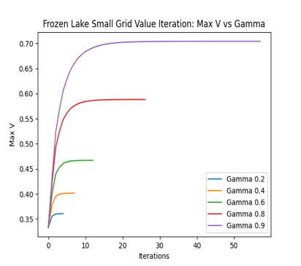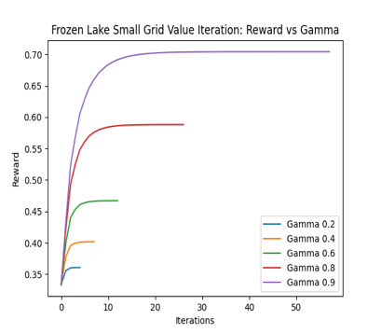

Fig 1: Value Iteration Convergence plots for Frozen Lake small grid

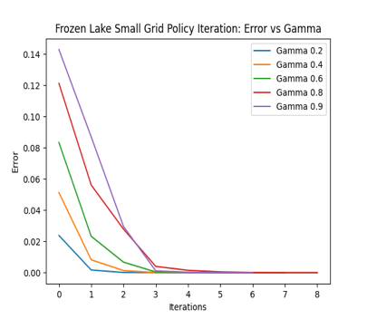

Fig 2: Policy Iteration Convergence plots for Frozen Lake small grid

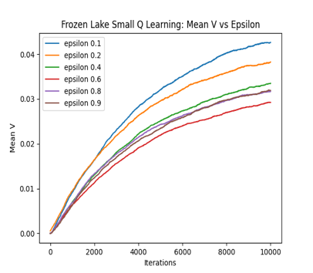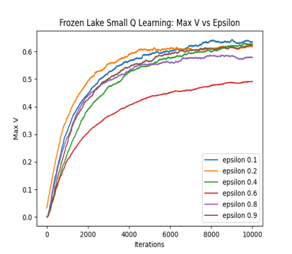

Fig 3: Q Learning convergence plots for Frozen Lake small grid

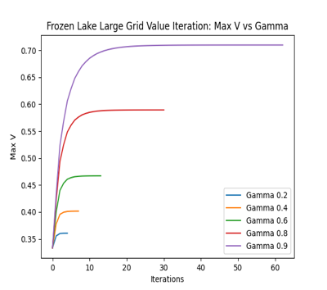

Fig 4: Value Iteration plots for Frozen Lake large grid size

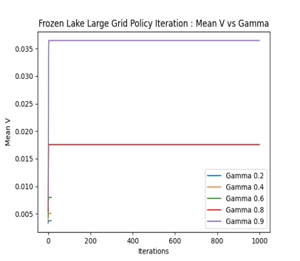

Fig 5: Policy Iteration plots for Frozen Lake large grid size

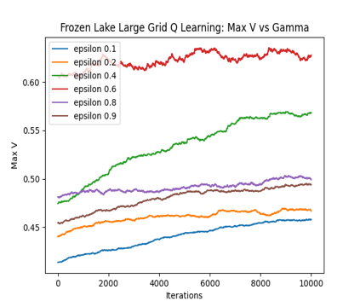

Fig 6: Q Learning plots for Frozen Lake large grid size

Value Iteration and Policy Iteration was run for different values of gamma. Lower gamma values put more emphasis on short term gains, higher gamma values put more emphasis on long term gains. Closer the gamma is to 1, closer the policy will be to the one that optimizes the gains over infinite time. Plots of Mean V, Max V, Rewards and Error vs Iterations for different values of gamma were generated. We would be using Max V plots and Mean plots primarily to demonstrate convergence. The flat lines in the Mean V and Max V plots signals convergence. From the charts in Fig 1, 2, 4 and 5, it is evident that higher value of gamma (gamma of value 0.9) gives us the best reward as it is focused on long term gains and would not get trapped in local optima. Lower values of gamma are converging at much lower rewards indicating local optima. I finalized the gamma of 0.9 for building the final Value Iteration and Policy Iteration model.

If we look at the charts in Fig 7, we can see that Value Iteration is converging at about 58 iterations whereas Policy Iteration is converging at 7 iterations for small grid frozen lake. This is in line with what we had hypothesized earlier. Policy Iteration converges faster than Value Iteration as one policy can be represented by infinite number of value functions. So, in Policy Iteration when we move from one policy to an improved policy, we have jumped over multiple value functions. If we look at the charts in Fig 8, we can see that Value Iteration is converging at about 62 iterations whereas Policy Iteration is converging at 1000 iterations for large grid frozen lake. For large problems, sometimes Policy Iteration take more and more time as it has large set of possible policies (because of the large number of states) to iterate upon.

For the small and large grid Frozen Lake problem, the Value Iteration and Policy Iteration converges at the same answer i.e., a reward of 0.7. The error plot supports the fact that the error for both VI and PI drops with each iteration and are converging with a minimal error value.

Unlike Value Iteration and Policy Iteration, Q Learning doesn’t know the model and rewards. I ran Q Learning algorithm with different values of epsilon by keeping the alpha (learning rate) and gamma constant. The epsilon parameter introduces randomness into the algorithm, forcing us to try different actions to avoid local optima. If epsilon tends to zero, we never explore but always exploit the knowledge we have. Epsilon value close to one force us to always take random actions and never use past knowledge. From the charts in Fig 3, we can see that a lower value of epsilon of 0.1 gives us better rewards than with higher epsilon. With such lower value of epsilon, the agent tries to learn from previous knowledge and acts based on that rather than taking random actions. It is to be noted that extremely lower value of epsilon might land our problem into a local optimum. From the charts in Fig 6, we see that an epsilon value of 0.6 gives us the best rewards for large grid Frozen Lake problem. For large problem with higher number of states, the model is giving more attention to exploration than exploitation of previous knowledge.

Because it is a model free learner, Q Learning finds it hard to converge. We can see from the charts in Fig 3 and 6, that the Max V plot is trying to consolidate but hasn’t converged perfectly as we would have liked. Since, it is hard for Q Learning to converge, we can assess if the variance of rewards in last few iterations is lower than certain threshold, if it is lower, we can declare convergence. It is evident that Q Learning is not performing as well as Value Iteration and Policy Iteration. Since, Q Learning doesn’t have access to the model and rewards, it works like an approximation algorithm and learns by visiting the state-action pair infinitely. Q Learning with an epsilon value of 0.1 is converging at a reward value of 0.6 for small grid and Q Learning with an epsilon value of 0.6 converged at a reward of about 0.65 for large grid. Overall, Q Learning results are sub-part with respect to Value Iteration and Policy Iteration possibly because it hasn’t visited the state action pairs infinitely.

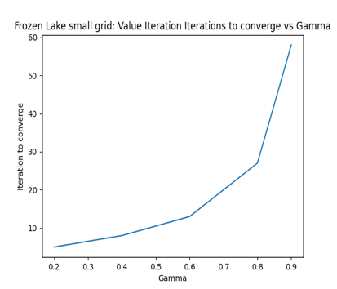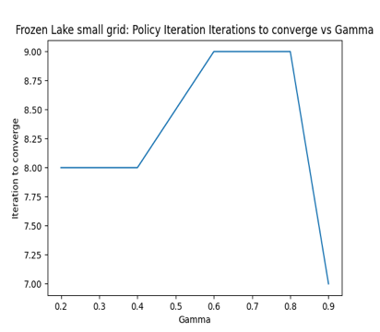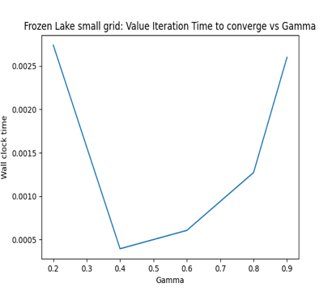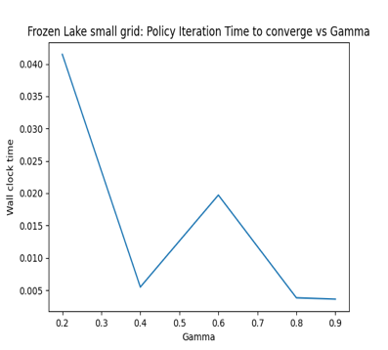

Fig 7: No. of iterations & Wall Clock time for VI and PI to converge at different gamma values for small grid Frozen Lake

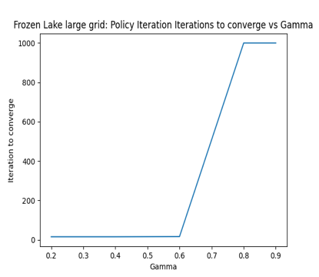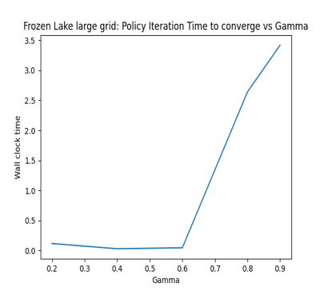

Fig 8: No. of iterations & Wall Clock time for VI and PI to converge at different gamma values for large grid Frozen Lake

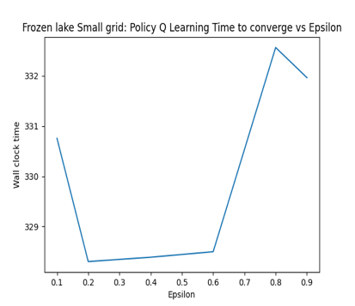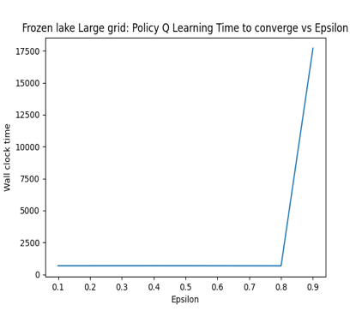

Fig 9: Wall clock time for Q Learning to converge at different epsilon values for small and large grid Frozen Lake

In Fig 7 and 8, for Value Iteration, the number of iterations taken to converge increases with increasing value of gamma. With higher value of gamma, it focuses more on long term gain and hence takes more iterations to converge. For Policy Iteration, the number of iterations to converge range from 7 to 9 for small grid world. However, for large grid world, Policy Iteration takes about 1000 iterations to converge for a gamma value of 0.9.

Value Iteration takes less wall clock time to converge compared to Policy Iteration as Policy Iteration performs both policy evaluation and policy improvement in each iteration compared to Value Iteration performing just value improvement in each iteration. With lower value of gamma, Value Iteration find tough to converge because of the volatility of short-term rewards. With increasing gamma, they reach global optima and take more time to converge. In Fig 9, Q Learning takes longer time to converge at higher value of epsilon as the agent’s actions are more driven by exploration than exploitation.

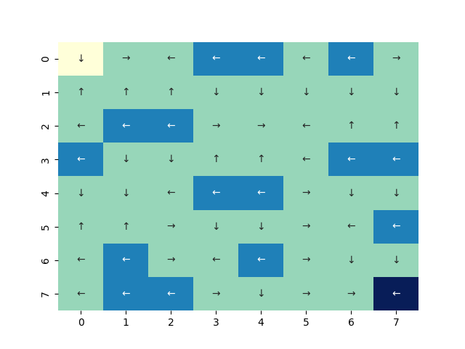

Fig 10: Policy Visual for Value Iteration, Policy Iteration and Q Learning from left to right for small grid Frozen Lake

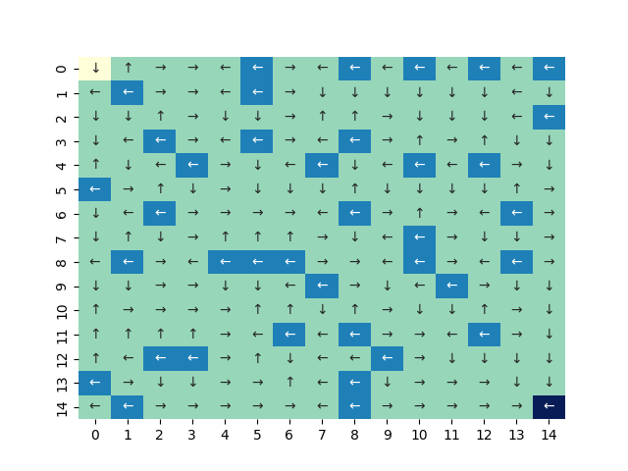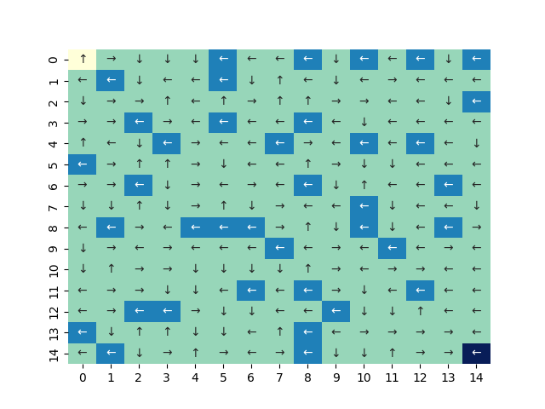

Fig 11: Policy Visual for Value Iteration, Policy Iteration and Q Learning from left to right for large grid Frozen Lake

The above charts in Fig 10 and 11 represent the policy generated for each of the algorithms for small and large grid frozen lake problem. Yellow block at the top-left corner and dark-blue block at the bottom right corner of the policy represent the start and goal position respectively. Light blue blocks represent the holes and green blocks represent the frozen blocks on which the agent can walk. The policy generated via Value Iteration and Policy Iteration are almost identical and they try to avoid holes in most cases barring few cases where it jumps into the hole. Overall, both Value Iteration and Policy Iteration does a great job by evading most of the holes and reaches the goal. Whereas Q Learning fails to learn much and bumps into the hole in lot of cases. Additionally, it is moving in the undesired direction when the agent would be at the block adjacent to the goal. That’s why we see sub-par rewards for Q Learning.

Model-free algorithms like Q Learning relies on trial-and-error method. During these trials, agent must decide the action. Some of these actions have never been taken before and some of the actions have been performed earlier and the agent might know the outcome. This concept of exploiting what the agent already knows versus exploring a random action is called exploration-exploitation trade-off. Initially, as the agent has limited knowledge, it needs to do sufficient exploration and improve its knowledge base. If the agent exploits its knowledge initially without exploring much, it might end up in local optima. More exploration in the final stages may not lead to optima. So, we need to keep a balance between exploration and exploitation. Hence, a decaying epsilon value is recommended.

1. **Value Iteration, Policy Iteration and Q Learning on Forest Management problem**

Value Iteration, Policy Iteration and Q Learning were implemented in the Forest Management problem of state size 20 and 400 for small and large problem respectively.

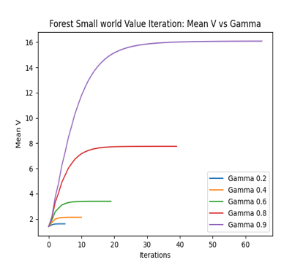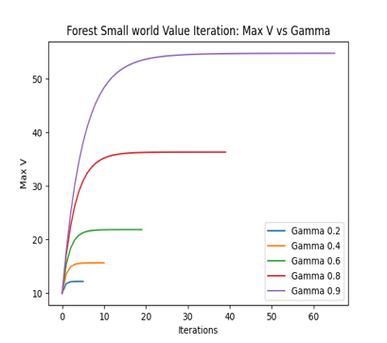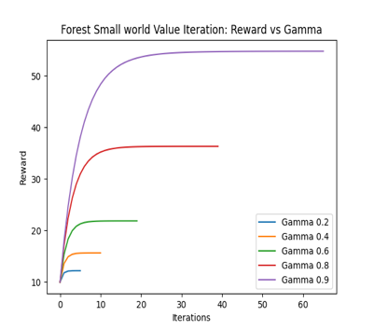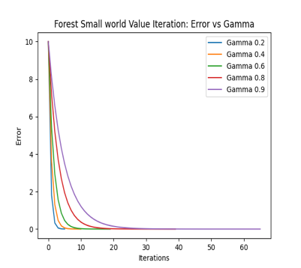

Fig 12: Value Iteration plots for Forest Management small world

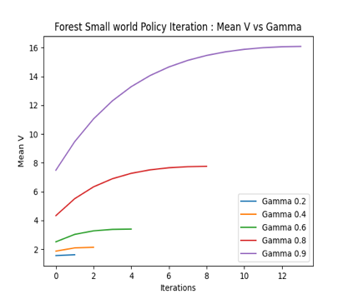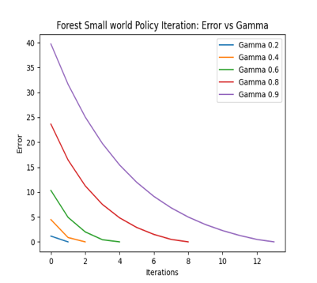

Fig 13: Policy Iteration plots for Forest Management small world

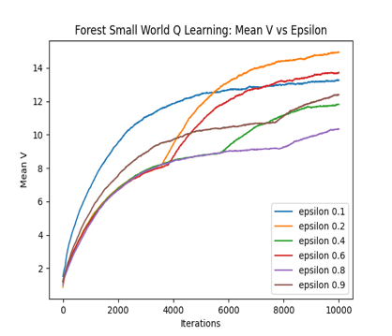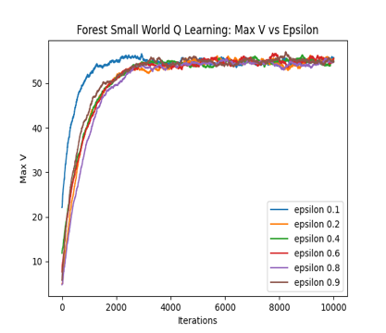

Fig 14: Q Learning plots for Forest Management small world

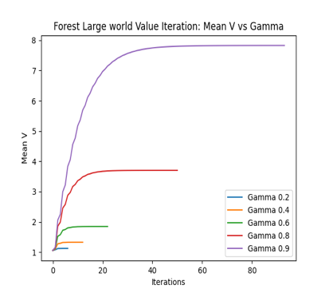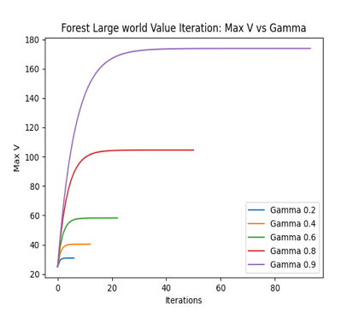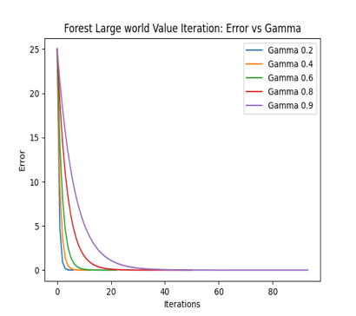

Fig 15: Value Iteration plots for Forest Management large world

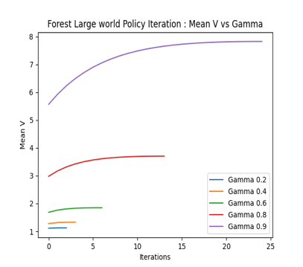

Fig 16: Policy Iteration plots for Forest Management large world

Fig 17: Q Learning plots for Forest Management large world

Plots of Mean V, Max V, Rewards and Error vs Iterations for both Value Iteration and Policy Iteration were generated for different values of gamma and studied. Again, we would be using Max V plots and Mean plots primarily to demonstrate convergence. The flat lines in the Mean V and Max V plots signals convergence. Charts in Fig 12,13, 15 and 16 suggest that higher value of gamma gives us the best reward as it is focused on long term gains and would not get trapped in local optima. Lower gamma values make the learner saturate at lower reward (local optima). Gamma value of 0.9 was selected for both Value Iteration and Policy Iteration.

From Fig 18, Value Iteration and Policy Iteration are converging at 63 and 14 iterations respectively for the small Forest world. From Fig 19, Value Iteration and Policy Iteration are converging at 92 and 25 iterations respectively for the large world Forest problem. In Policy Iteration, while we are moving from one policy to another, we are essentially jumping over multiple value functions. Value Iteration and Policy Iteration are converging at the same value i.e., a reward of about 55 for the small world Forest problem and a reward of about 174 for the large world Forest problem. The error plots also suggest that error is diminishing with each iteration and reduces to near zero during convergence.

Q Learning algorithm was run at different epsilon values with a constant alpha and gamma value. The epsilon parameter controls the exploration-exploitation trade-off. Lower value of epsilon encourages exploiting the previous knowledge and higher value of epsilon encourages exploration of different actions. From Fig 14 and 17, we can deduce that epsilon of 0.1 converges faster. For our problem, the agent is more inclined towards taking actions based out of previous knowledge. Q Learning algorithm converges for both the small and large world Forest problem with a reward of about 55 and 175 respectively which is close to what we have for Value Iteration and policy Iteration. Thus, we can conclude that Q Learning, despite being a model free learner, works well for this problem.

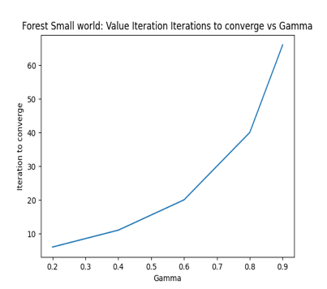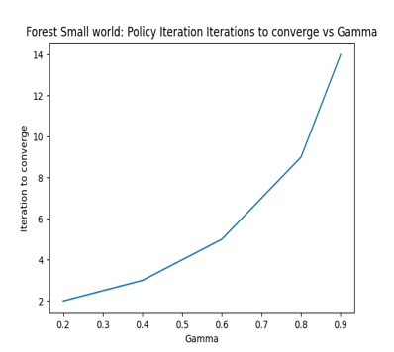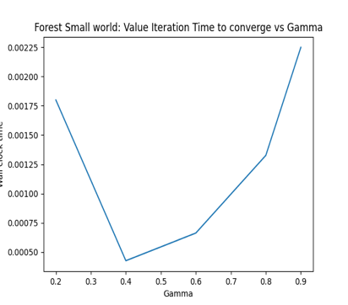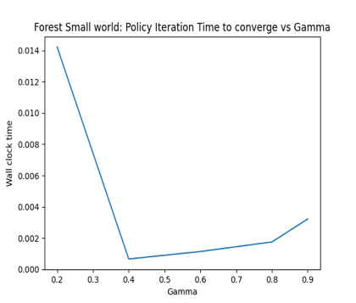

Fig 18: No. of iterations & Wall Clock time for VI and PI to converge at different gamma values for small world Forest problem

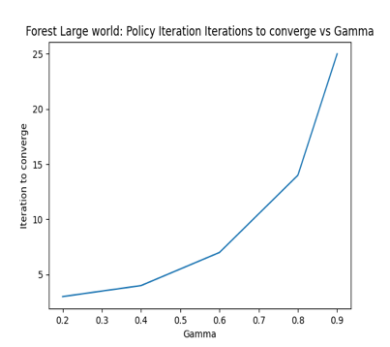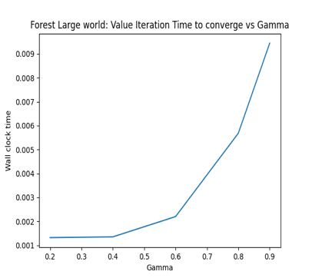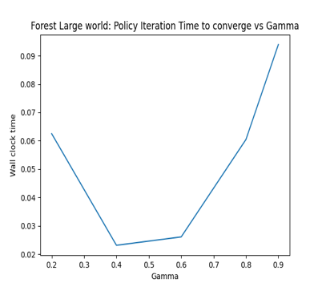

Fig 19: No. of iterations & Wall Clock time for VI and PI to converge at different gamma values for large world Forest problem

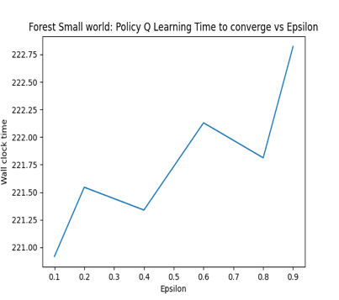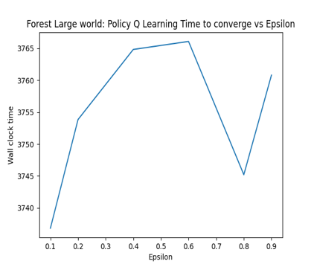

Fig 20: Wall clock time for Q Learning to converge at different epsilon values for small and large grid Frozen Lake

For Value Iteration and Policy Iteration, number of iterations taken to converge increases with increasing value of gamma as it focuses on long term gain. Hence, both Value Iteration and Policy Iteration takes more time to converge at higher values of gamma. In terms of absolute value, Value Iteration takes lesser wall clock time to converge compared to Policy Iteration as Policy Iteration performs both policy evaluation and policy improvement in each iteration compared to Value Iteration performing just value improvement in each iteration. Fig 20 suggests that Q Learning takes much longer time to converge as it is a model free learner, and it must visit the state-action pair infinitely.

Value Iteration policy 🡪 [0, 1, 1, 1, 1, 1, 0, 0, 0, 0, 0, 0, 0, 0, 0, 0, 0, 0, 0, 0]

Policy Iteration policy 🡪 [0, 1, 1, 1, 1, 1, 0, 0, 0, 0, 0, 0, 0, 0, 0, 0, 0, 0, 0, 0]

Q Learning policy 🡪 [0, 1, 1, 0, 1, 0, 0, 1, 1, 1, 1, 1, 1, 0, 1, 0, 1, 0, 0, 0]

The above policies are the policies generated by each of the technique for small world Forest problem of size 20. Value Iteration and Policy Iteration generates the exact same policy. It says to cut the forest in the 2nd, 3rd, 4th, 5th and 6th year and wait for the remaining years. Q Learning suggests a different policy, but the rewards achieved through this policy was as good as Value Iteration and Policy Iteration.

I didn’t add the policy visual for large world Forest Management problem because of the size and it would be hard to visualize.

In Q Learning, the agent takes a call if it should explore more or use the previous knowledge while deciding actions. Initially, when the agent has limited knowledge, it should prefer exploration over exploitation of previous knowledge. And towards the final stage it should prefer using the previous knowledge to decide the action. This is called Exploration-Exploitation trade-off. A decaying epsilon value would ensure the trade-off is taken care of.

**References**:

1. <https://pymdptoolbox.readthedocs.io/en/latest/>
2. <https://www.baeldung.com/cs/ml-value-iteration-vs-policy-iteration>
3. <https://stackoverflow.com/questions/37370015/what-is-the-difference-between-value-iteration-and-policy-iteration>
4. <https://www.baeldung.com/cs/epsilon-greedy-q-learning>
5. https://stackoverflow.com/questions/28937803/what-is-the-difference-between-q-learning-and-value-iteration
6. <https://stats.stackexchange.com/questions/396823/q-learning-shows-worse-results-than-value-iteration>
7. <https://stackoverflow.com/questions/59023468/why-is-policy-iteration-faster-than-value-iteration>
8. https://github.com/hiive/hiivemdptoolbox/blob/master/hiive/mdptoolbox/openai.py